Payroll Management System for Information Technology Company

Use-Case Specification: Viewing Department

Version 1.0

Revision History

|  |  |  |  |
| --- | --- | --- | --- |
| **Date** | **Version** | **Description** | **Author** |
| 31/10/2019 | 1.0 | Final Draft | Bùi Tuấn Anh |
|  |  |  |  |
|  |  |  |  |
|  |  |  |  |

Table of Contents

1. Viewing Department 4

1.1 Brief Description 4

1.2 Actor 4

2. Flow of Events 4

2.1 Basic Flow 4

3. Special Requirements 5

4. Preconditions 5

5. Postconditions 5

6. Extension Points 5

# Viewing Department

## Brief Description

This use case defines steps of showing a department in the system. Administrator can easily show a department in the database.

## Actor

Administrator.

# Flow of Events

## Basic Flow

The system administrator selects the department information to show the value. The administrator shows the database management parameter that holds department information. The administrator displays the department management parameter value.

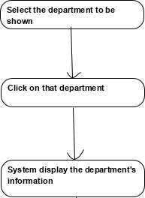



Basic flow of Viewing Department

# Special Requirements

No special requirements.

# Preconditions

Admin login first.

# Postconditions

No postconditions.

# Extension Points

Admin can search department by name to update or delete.